## Secondary Research/ Bibliographical Journal:

### What is a Math Fair?

1. SNAP Mathfairs. (n.d.). Retrieved May 11, 2016, from http://www.mathfair.com/

Are you interested in inspiring your students in Mathematics?  Become better problem solvers to think outside the box?  How about sharing with them some wonderful and fun recreational mathematics problems?   
  
[***SNAP Math Fairs***](http://www.mathfair.com/) will do just that!  And this website will not only show you how but will also provide all the resources you'll need to get started!  
  
A SNAP math fair is a non-competitive event that gives teachers an opportunity to have their students do problem solving with a particular goal in mind. The math fair can be adapted to almost any curriculum and set of standards, and it will motivate and inspire all of the students.  
  
This website describes what a SNAP math fair is, how it differs from a conventional science fair, and why it works so wonderfully.  
  
It also explains how to organize a SNAP math fair, how some schools have adapted the concept to their particular academic objectives, and provides resources and contacts to help you get started.  
  
SNAP math fairs have a long and respectable track record. Students and teachers have presented them with great success in a variety of jurisdictions — in Sweden, in Africa, in Austria, in Canada, and in the United States.

## **A Quick Overview**

A SNAP Math fair is not like a traditional science fair. Although there is a superficial resemblance, it differs in its structure and its scope. Like a science fair, the math fair has tabletop displays presided over by students, but the similarity does not extend much beyond this.  
  
A SNAP math fair is:

* **S**tudent-centered,
* **N**on-competitive,
* **A**ll-inclusive, and
* **P**roblem-based.

The purpose of a SNAP math fair is to provide a meaningful problem-solving experience for all students. These four guidelines make the math fair appeal to all students at all levels. We believe that once you have tried a SNAP math fair, you will incorporate it as part of your regular math curriculum.

____________________________________________________________________

### What will I require to succeed in this assignment?

1. How to Get More Grit in Your Life - Freakonomics. (n.d.). Retrieved May 11, 2016, from http://freakonomics.com/podcast/grit/

“Grit”

* “Deliberate practice” is more important than the talent you were born with.
* Talent is vastly overrated; practice is critical.
* How do you force yourself to practice?
  + You have GRIT! … also you can obtain more grit
* Duckworth family – WRONG THINKING –
  + “you are no genius” from Dad
  + if you are not smarter than everyone else you have no hope
* brains matter less than grit
  + - natural ability does not produce greatness
* greatness is something you accomplish yourself
* “Grit is passion and perseverance for long term goals”
* Gritty people have:
  + **Interest**
    - passion has to come first
    - Finding your passion is hard. Needs fostering. Exploration.
    - you need to learn to substitute nuance for novelty
  + **Practice**
    - “deliberate” practice
    - 10 years or 10 000 hours of effortful practice makes a world class expert
    - focus performance on one improvement at a time
    - “labouring” “un-fun” “reflection”
  + **Purpose** 
    - connecting work/hobby to people who are not you
    - see how work is connected to teammates/sport as a whole
  + **Hope**
    - power of positive thinking to carry you through problems, speed bumps and 10,000 hours practice
    - you need to believe effort can make changes

### Some more information?

1. The key to success? Grit. (n.d.). Retrieved May 11, 2016, from https://www.ted.com/talks/angela_lee_duckworth_the_key_to_success_grit?nolanguage=en.

Leaving a high-flying job in consulting, Angela Lee Duckworth took a job teaching math to seventh graders in a New York public school. She quickly realized that IQ wasn’t the only thing separating the successful students from those who struggled. Here, she explains her theory of “grit” as a predictor of success.

### Here are some grid games that have been used by teachers in the past to teach students or help them with math. Hopefully it might stimulate some ideas!

1. John, B. K. (n.d.). Math Grid Games. Retrieved May 11, 2016, from http://www.teachingthelittlepeople.com/the-big-picture-goals-of ecsped/preacademics/math-literacy/grid-games-in-preschool/

### Here’s how it goes:

In my goal to promote more [“in action”](http://teachingthelittlepeople.blogspot.com/2012/09/math-mats-in-preschool.html) math activities in my classroom, I have decided to increase four main types of activities in my classroom.  They are:

1. Math Mats
2. Math Grid, Line and Path Games
3. Sorting/Classifying Activities
4. Graphing

Today I’m going to talk about Grid, Line and Path Games.  In short, these are simple games that promote counting, one-to-one correspondence, identifying numbers, and counting concepts.

**Grid Games:**

A grid game is a grid or array of objects on a paper that serves as a game board.

**Materials Needed for Grid Games:**

· A laminated game board for each student (Here are some examples of boards:)

|  |
| --- |
| [Grid Games in Preschool](https://www.teacherspayteachers.com/Product/Apple-Printable-Activities-for-Preschool-and-Kindergarten-322454) |
|  |

|  |
| --- |
| [Grid Games in Preschool : teachingthelittlepeople.com](https://www.teacherspayteachers.com/Product/Tree-Math-Play-Dough-Mats-731418) |
|  |

* A 1-3 spinner or die (a spinner that has the numbers 1, 2 and 3, or a die that has the numbers 1, 2 and 3. ) You can also use a 1-5 spinner or a 1-5 die depending on the needs of your students.
* Coordinating cards or manipulatives for tokens (Good tokens can be any kind of erasers, counters, or small toys that go with the theme of the game.)  Here are a few examples of cards that can be used with the above grid games (these are from my [Tree Mat Printables](https://www.teacherspayteachers.com/Product/Tree-Math-Play-Dough-Mats-731418). :

[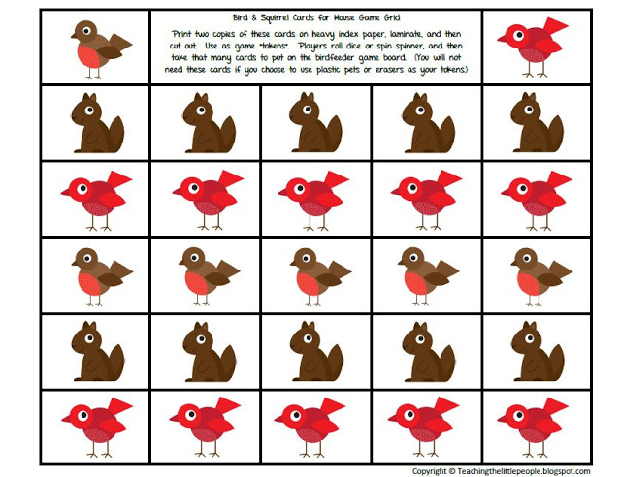](https://www.teacherspayteachers.com/Product/Tree-Math-Play-Dough-Mats-731418)

[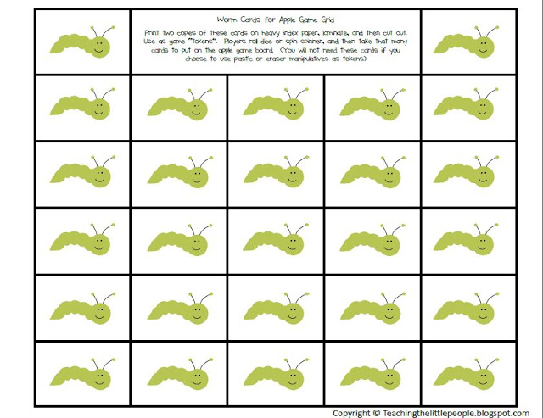](https://www.teacherspayteachers.com/Product/Tree-Math-Play-Dough-Mats-731418)

 · Basket to hold manipulatives

**Instructions:**To play the game, students roll the die or spin the spinner.  They then take the number of cards or other manipulatives that they rolled and put them on the grid.   As they do, you promote learning by talking about what they have done:  
  
*“Which apple has more worms?”*  
*“How many worms do you need to put a worm on every apple?”*  
*“This row of apples is almost filled up.  Look, you only have two more apples with  no worms.”*  
  
**Varying Game Levels:**A simple version of the game would be that students place one card or manipulative on each picture on the grid as they roll a certain number on the die or spinner.  When a player gets all of his pictures “filled” with one manipulative, they are done (or they win).

To make the game more complex, let players place their manipulatives/cards on the pictures as they wish (not necessarily one item per picture).  Allowing them to play this way will make the game more complex as players create, quantify, and compare sets of items as they put the them on the grid pictures.  It will also provide opportunity for them to sort the cards/manipulatives in different ways as they play.

Game difficulty can be also adjusted by changing type of die.  (You can use a die/spinner with either dots or numerals depending on the needs of your students.  You can also use die/spinner with more or less numbers, such as one with only numbers 1-3, or one with 1-5 on them.

Student can also use two dice together to encourage addition skills.  
  
**Line Games and Path Games:**  
Line and Path games are basically what you think of when you think of board games.  The students continue down a path as they roll dice or spin a spinner.    
  
Here are some examples of Line and Path Games (these are from my[Apple Activities Unit](https://www.teacherspayteachers.com/Product/Apple-Printable-Activities-for-Preschool-and-Kindergarten-322454)):

[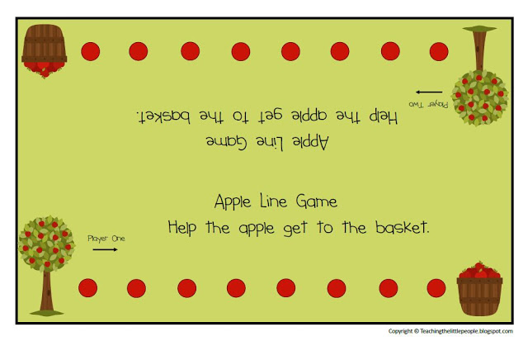](https://www.teacherspayteachers.com/Product/Apple-Printable-Activities-for-Preschool-and-Kindergarten-322454)

With a line game like the one above, players start on the tree and use a die or spinner to advance down the line.  When they reach the basket, they get to collect an apple game token, and then can go across again.  This simple game is best for beginning counters.

[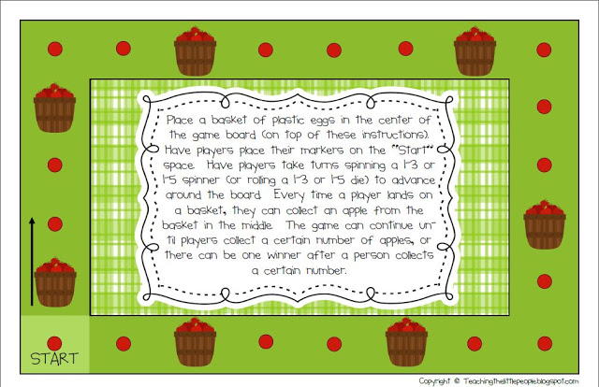](https://www.teacherspayteachers.com/Product/Apple-Printable-Activities-for-Preschool-and-Kindergarten-322454)

With a continuous path game like the one above, the players begin on the “start”  space and use dice or a spinner to determine how many spaces they can move.  Every time they land on a basket, they get to collect an apple token (which are placed in a basket in the middle of the game board before the game begins).

For more about Grid, Line and Path Games, I would recommend the following book:

[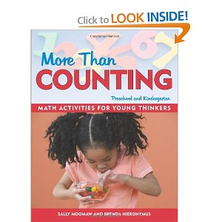](http://ecx.images-amazon.com/images/I/51OY85OHXeL._BO2,204,203,200_PIsitb-sticker-arrow-click,TopRight,35,-76_AA300_SH20_OU01_.jpg)

_____________________________________________________________

### Here is the summary the Malcolm Gladwell: Outlier book:

1. Outliers: The Story of Success Summary - eNotes.com. (n.d.). Retrieved May 11, 2016, from http://www.enotes.com/topics/outliers-the-story-of-success

Outliers—those among us who are the brightest and the best, the talented and the famous—are the subject of Malcolm Gladwell's Outliers, published in 2008 by Little, Brown and Company. InOutliers, Gladwell attempts to answer, "What makes some people successful while others cannot seem to realize their full potential?" In contemporary U.S. society, people are considered successful when they embody particular traits and characteristics: diligence, self-sacrifice, intelligence, talent. However, Gladwell says that the conditions and circumstances surrounding our lives are the significant influential factors that determine our success, not our inner ability or talent.

Let us take ice hockey as an example. The greatest ice hockey stars have been strong, driven, and—according to Gladwell—born in the first three months of the calendar year, making them physically larger and more capable compared to their less mature peers. Gladwell cites chance opportunities, such as birth during a certain time period and demographic luckiness, to be overwhelming factors in determining a person's success. He shares the stories of many outliers who have met their potential by harnessing the chance opportunities that have come their way.

The structure of Outliers is based on the case studies that Gladwell uses to support his claims. The two parts “Opportunity” and “Legacy” are further divided into chapters that are devoted to particular cases. Within the chapters, Gladwell challenges commonly held beliefs by finding people whose circumstances go against the grain—outliers in a world of sameness. He shares the story of Christopher Langan, a man who has an incredibly high IQ score, yet works on a horse farm, spending his free time exploring and researching questions that will never be published or recognized. Growing up in an unstable family situation, Langan never had opportunities for success and has had to work alone. And as Gladwell points out, “no one ever makes it alone.”

Outliers received much acclaim and became an international best seller shortly after its publication. Gladwell’s writing style is accessible to the general public, and his persuasive appeals capture the reader while drawing him or her into the argument. However, Gladwell has been criticized by several reviewers who argue that while Gladwell’s claims throughout Outliers are firm, the logical reasoning behind these claims is faulty. Further, critics say that Gladwell does not discuss the methodology that informs his study, which leaves the reader questioning the validity of the case studies, and that Gladwell presents an oversimplified view of the nature of success and opportunity.

Despite these criticisms, Malcolm Gladwell's Outliers still offers readers a challenging view on the nature of success in our society.

## [Outliers: The Story of Success Chapter Summaries](http://www.enotes.com/topics/outliers-the-story-of-success)

## [Introduction Summary](http://www.enotes.com/topics/outliers-the-story-of-success)

In the introduction to Outliers: The Story of Success, Malcolm Gladwell begins by giving the definition of the word outlieras a person, situation, or thing that is different from others. This definition of something that is markedly different from the normal or the average is the foundational principle of his book. Gladwell studies people and situations that are above average or that stand out from the norm, and he looks into all of the different factors that played a role in creating their success.

To explain the concept of an outlier in more depth, Gladwell describes the people of an Italian village named Roseto Valfortore. Many of these Italians emigrated and ended up all living in the same small town in Pennsylvania, which they named Roseto. Over time, they remained a close-knit community, closed off from the rest of the world for the most part.

What is interesting about their community in Pennsylvania is that hardly any of the men in the city suffer from heart disease. This was discovered in the 1950s when a doctor, Stewart Wolf, was traveling in the area. One of the local physicians told him that he rarely saw anyone from the small town of Roseto for heart disease. This intrigued Wolf, who then did extensive studies on the people of the town including their physical makeup, culture, lifestyle, and all other possible factors that could play a role in heart disease. What the physician discovered was quite interesting: people in the town right next to Roseto suffered from normal levels of heart disease, as did people who moved away from Roseto. Also, the Rosetans did not eat healthily, exercise much, or have very active lifestyles. Despite all of these factors, the Rosetan community still had hardly any heart disease. Wolf concluded that their lack of heart disease was caused by their attitude and lifestyle. The people in the community were close; they knew each other well, supported each other, said hello to each other, and lived with multiple generations in their homes. This close-knit support group was the only explanation for the lack of heart disease. It was concluded that Roseto, an outlier for being different from the norm when it came to heart disease, was healthy not because of individual efforts to stay healthy but because the people lived in a supportive environment surrounded by their close friends and family members.

Gladwell uses the example of Roseto to set up the premise of his book: successes and failures can be explained in unexpected ways; too often, we do not take those factors into consideration as much as we should.

### Few ideas not on the grid:

* Battleship
* Multiplication times table
* Yugioh
* Bakugan
* Digimon